Capstone Project
SQL Murder Mystery: “Who Killed the CEO?”
Investigation Step—1:
Identify where and when the crime happened
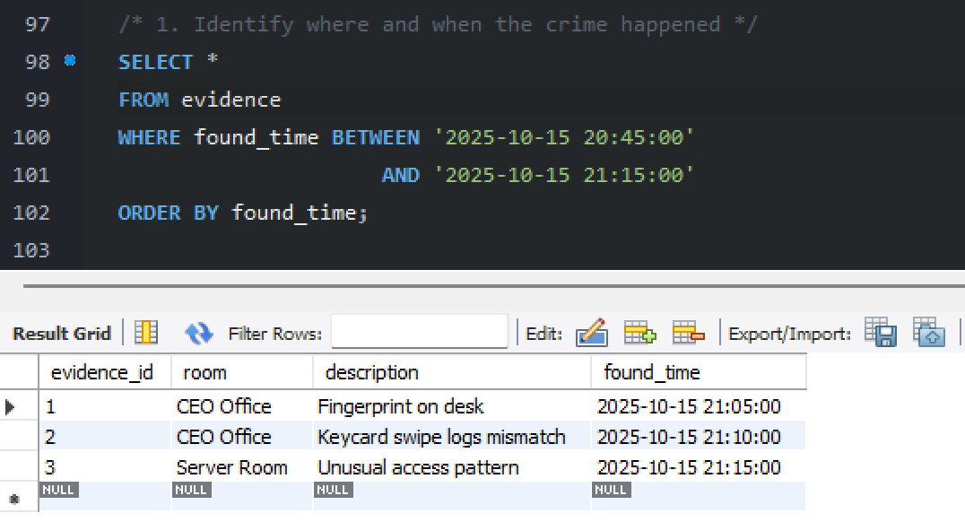
Investigation Step-2:
Analyze who accessed critical areas at the time
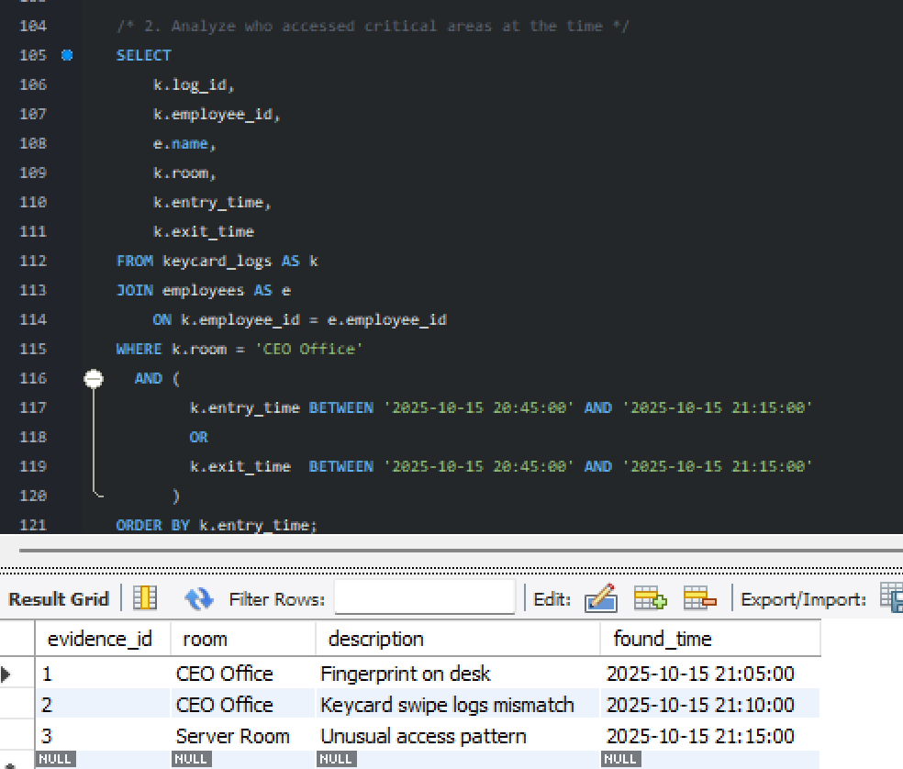
Investigation Step-3:
Cross-check alibis with actual logs
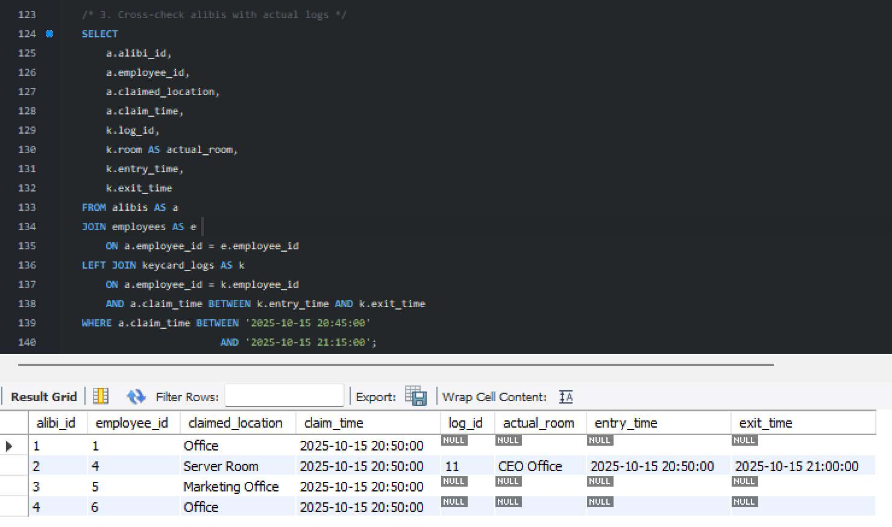
Investigation Step-4:
Investigate suspicious calls made around the time
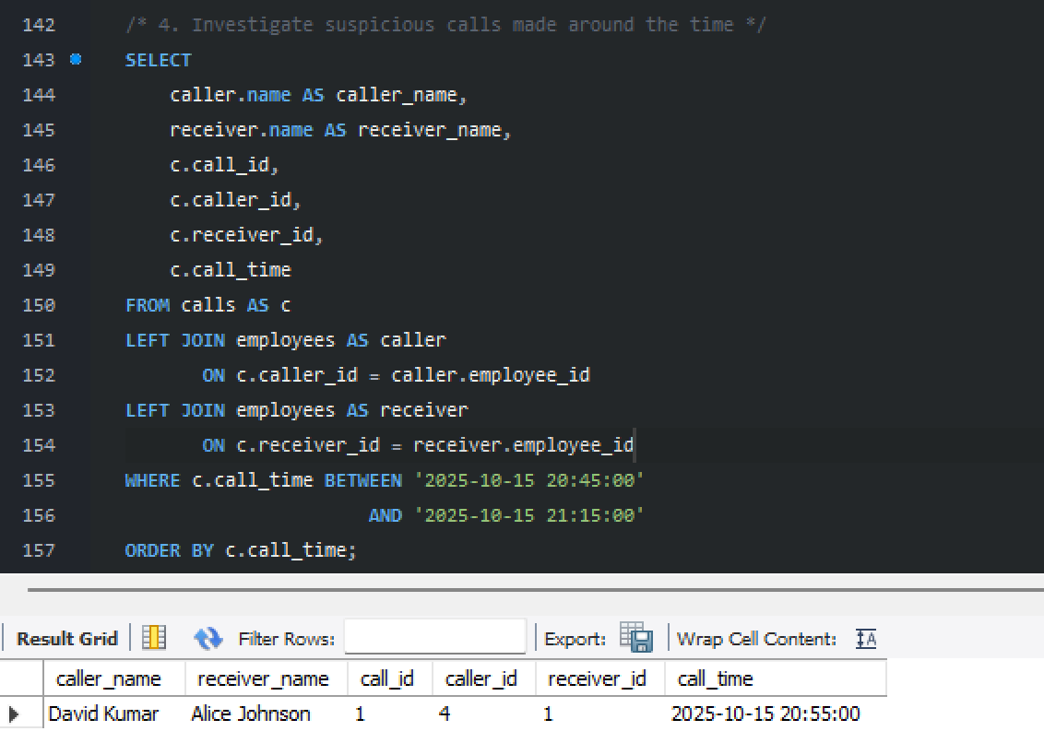

Investigation Step-5:
Match evidence with movements and claims
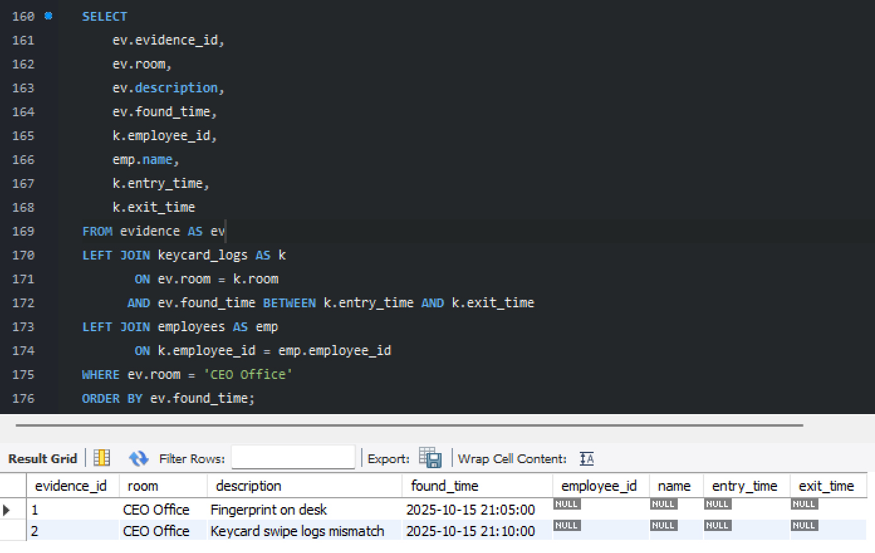

Final Investigation Step:
Combine all findings to identify the killer
